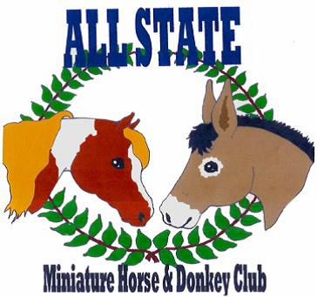

ALL STATE MINIATURE HORSE & DONKEY CLUB

2016 Sponsor Information

Dear Friends, Families, Neighbors and Sponsors,

The All State Miniature Horse and Donkey Club is a local organization located in
Fayetteville, PA.

Our goal is to create responsible ownership of the miniature breeds and to introduce
owners to the versatility and fun associated with them.

Throughout the year we plan to host clinics and educational seminars on the ownership, care and showmanship of the miniature horse and donkey. We hold 3 miniature horse and donkey shows during the year. Over the course of these shows, the exhibitors may accumulate points and be awarded with yearend awards as well.

In support of our organization your business will have an ad placed in our All State Miniature Horse and Donkey Club Show Program and Year End Awards Program. Our Show Programs will be distributed at each show to all participants and guests, along with being distributed at local businesses before the shows.

If you elect to sponsor a class at the show, your name and/or company's name will be mentioned as sponsoring that class during our shows. With any sponsorship (except blurbs) you and/or your company will be listed on our website sponsor page.

Our website is www.allstateminiclub.weebly.com and our email is allstateminiclub@yahoo.com.

Thank you for your support.

Melissa Foltz, President , and the Officers and Board of the A.S.M.H.D.C.

