Point Sign Up
Fee: $10.00
Per horse/exhibitor Combination Make Checks Payable:
All State Miniature Horse and Donkey Club
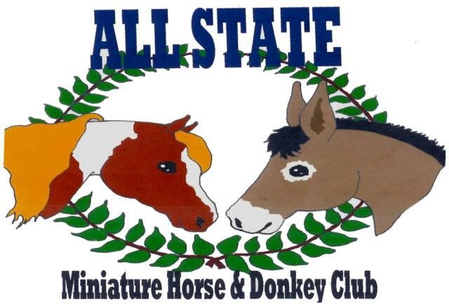
*****You must be a current member of All State Miniature Horse and Donkey Club and show in 1 of 2 shows to be eligible to sign up for points and earn year-end awards.*****
Date:_____________________________ Horse/Exhibitor’s Number:____________________
Horse’s Name:__________________________________________________________________

Exhibitor’s Name:_______________________________________________________________

Exhibitor’s Birthdate (If Youth):____________________________________________________

Complete Address:______________________________________________________________

Phone Number:_________________________________________________________________

Email Address:__________________________________________________________________

**Please keep your same number all year long. Please Do Not Loose! If you misplace your number you will need to make a new card using the same number.

